1)  Created Java file (uetrGeneraotr.java) and prepared the jar file (uetr.jar).  Copied this .jar file under below path "fs/public/code/jar".  Give read/write access to this jar.

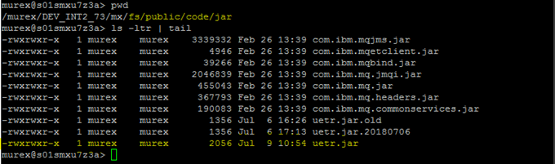

2) Update the **service.mxres** under fs/public/download, add this newly added jar file in the link.

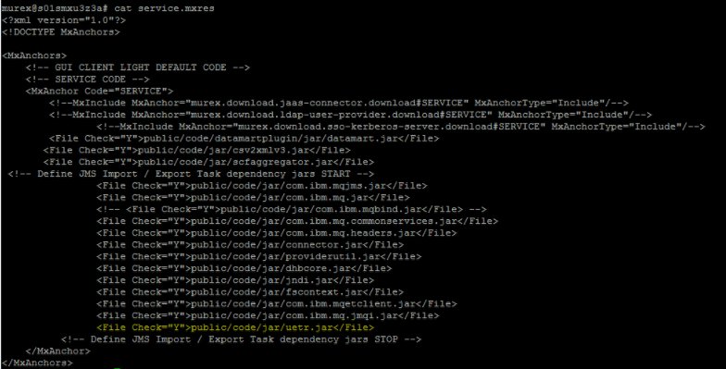

3) Update the file: **datadictionaryxslparser.mxres** under fs/public/mxres/mxdictionary/client

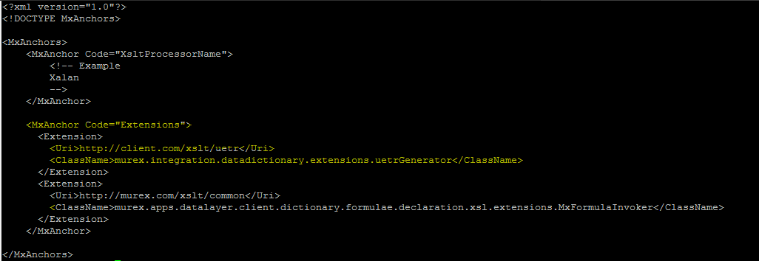

4) Stop and Start the MX services, and development and test the datadictionary formula:

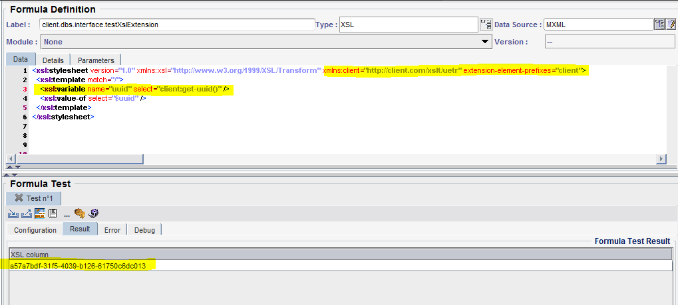

5) Java program

